An

Artificial Intelligence Course PBL Report on
Chess Move Recommendation
submitted in partial fulfillment of the requirements for the award of the degree of

BACHELOR OF TECHNOLOGY IN
COMPUTER SCIENCE AND ENGINEERING - DATA SCIENCE
By

24R11A6702 – A.Akshara
24R11A6727 – MD.Saniya begum
24R11A6740 – S.Sairam
Under the esteemed guidance of Mrs. Rama Aruna
Assistant Professor

Department of
Computer Science & Engineering –Data Science

GEETHANJALI COLLEGE OF ENGINEERING & TECHNOLOGY (GCET)
Approved by AICTE, New Delhi, Affiliated to JNTUH University, Hyderabad and Accredited by NAAC . Cheeryal(V), Keesara(M), Medchal(Dist.), Telangana – 501 301.
(An Autonomous Institution)

October, 2026
GEETHANJALI COLLEGE OF ENGINEERING & TECHNOLOGY (GCET)
Approved by AICTE, New Delhi, Affiliated to JNTUH University, Hyderabad and Accredited by NAAC & NBA. Cheeryal(V), Keesara(M), Medchal(Dist.), Telangana – 501 301.
(An Autonomous Institution)

DEPARTMENT OF CSE - DATA SCIENCE



CERTIFICATE

This is to certify that the B.Tech PBL Project report entitled “Chess move recommendation” is a bonafide work done by A.Akshara bearing 24R11A6702, MD.Saniya Begum bearing 24R11A6727 and S.Sairam bearing 24R11A6740 in partial fulfillment of the requirements for the award of the degree of Bachelor of Technology in Computer Science and Engineering – Data Science from Jawaharlal Nehru Technological University, Hyderabad during the year 2026-2027.

Internal Guide HOD, CSE-DS

Mrs. Rama Aruna Dr. D.Sujatha
Assistant Professor Professor

External Examiner

DECLARATION BY THE CANDIDATE

We, A.Akshara bearing 24R11A6702, MD.Saniya Begum bearing 24R11A6727 and S.Sairam bearing 24R11A6740 hereby declare that the project report entitled “Chess Move Recommendation” is done under the guidance of Mrs. Rama Aruna, Department of Computer Science and Engineering – Data Science, Geethanjali College of Engineering and Technology (GCET), Cheeryal, Hyderabad is submitted in partial fulfillment of the requirements for the award of the degree of Bachelor of Technology in Computer Science and Engineering-Data Science.

This is a record of bonafide work carried out by us and the results embodied in this project have not been reproduced or copied from any source. The results embodied in this project report have not been submitted to any other University or Institute for the award of any other degree or diploma.

24R11A6702-A.Akshara,

24R11A6727 -MD.Saniya Begum,

24R11A6740 -S.Sairam.

ACKNOWLEDGEMENTS

First and foremost, we express our sincere thanks for the guidance and encouragement rendered by Mrs. Rama Aruna, Assistant Professor in the Department of Computer Science & Engineering – Data Science, Geethanjali College of Engineering & Technology (GCET), Cheeryal, Hyderabad. We extend our gratitude for his / her advice and guidance during the progress of this project work.
Secondly, We express our sincere thanks to Sujatha, Professor & Head, Department of CSE-DS, GCET who stood as silent inspiration behind this project. Our heartfelt thanks for his endorsement and valuable suggestions.
We wish to express our profound thanks to Dr. V. Madhusudan Rao, Professor & Dean, School of CS & I for motivating and guiding us during this project work.
We wish to express our heartfelt thanks to Dr. K. Sagar, Principal, GCET for providing necessary facilities to make this project a success.
We thank all the members of teaching and non-teaching staff members, and also who have assisted us directly or indirectly for successful completion of this project.
Finally, We would like to express our sincere gratitude to our parents who are constantly encouraging us through-out our lives and for completion of this project.

24R11A6702 -A.Akshara, 24R11A6727 -MD.Saniya Begum, 24R11A6740 -S.Sairam.

TABLE OF CONTENTS
- Abstract 5
- Introduction 6
  - About the Project
- System Analysis 10
  - Existing System
  - Proposed System
  - System Configuration
  - Scope of the Project
- System Design 13
  - System Design
  - Architecture Diagram
- Implementation 16
  - Technologies used
  - Code
  - Output
- Conclusion 23
- References 24

ABSTRACT

The Chess Move Recommendation System is an Artificial Intelligence-based project that demonstrates the application of intelligent decision-making techniques in a strategic game environment. Chess involves a large number of possible moves and requires players to analyze the current board position and predict possible future moves. This project presents an AI-based solution developed using the Python programming language, which analyzes a given chess position and recommends the most suitable move for the player.
In this approach, the chess board is represented as a computational state, and possible legal moves are generated and evaluated by the system. The Minimax algorithm is used to explore possible future game states by considering both the player's and opponent's moves. Alpha-Beta pruning is incorporated to eliminate unnecessary branches of the search tree, thereby reducing the number of positions that need to be evaluated and improving the efficiency of the decision-making process. A heuristic evaluation function is also used to assess board positions based on factors such as piece values, piece positioning, and king safety.
The system allows users to enter moves and obtain AI-based recommendations for the current board position. It demonstrates how Artificial Intelligence, game theory, search algorithms, and heuristic evaluation can be combined to solve complex decision-making problems. The project provides a practical understanding of how AI can analyze game states, predict possible outcomes, and select an appropriate action while efficiently managing a large search space.

INTRODUCTION

https://github.com/amgothuakshara/chess-move-recommendation

https://github.com/Saniyabegum-04/Chess_Move_Recommendation_System.git

About the Project
The Chess Move Recommendation System is an Artificial Intelligence-based application designed to analyze chess positions and recommend a suitable move for the player. Chess is a strategic board game in which players need to analyze the current position, consider possible moves, and predict the opponent’s responses. Due to the large number of possible moves and game states, chess provides a suitable environment for demonstrating Artificial Intelligence and intelligent decision-making techniques.
In this project, the chess board is represented as a computational state containing the positions of all the pieces. Based on the current board position, the system generates possible legal moves and analyzes the resulting game states. The Minimax algorithm is used to explore possible moves by considering both the player's moves and the opponent's best responses. This enables the system to select a move that provides a better outcome for the player.
To improve the efficiency of the search process, Alpha-Beta pruning is incorporated into the Minimax algorithm. It removes branches of the search tree that do not need to be explored, thereby reducing the number of positions evaluated and allowing the system to make decisions more efficiently.
The system also uses a heuristic evaluation function to estimate the strength of a chess position. The evaluation considers important factors such as the relative value of chess pieces, their positions on the board, and king safety. Based on this evaluation, the system compares different possi ble game states and recommends the most suitable move.
The proposed system provides an interactive environment where users can enter chess moves and receive an AI-based move recommendation. It demonstrates the practical application of Artificial Intelligence, game theory, search algorithms, and heuristic evaluation in solving complex decision-making problems.

SYSTEM ANALYSIS

Existing System

The existing Chess game system is mainly based on manual gameplay, where players analyze the chess board and decide their moves based on their own knowledge, experience, and strategic thinking. In a traditional chess environment, the player must identify possible legal moves, evaluate the current board position, and predict the opponent’s possible responses before making a move.
The main characteristics and limitations of the existing system are:

Characteristics:
1. Players manually analyze the current chess board position.
2. Players select and perform legal chess moves.
3. The game follows standard chess rules and turn-based gameplay.
4. Players need to use their own knowledge and experience to determine suitable moves.
5. The outcome depends largely on the player's decision-making and strategic skills.

Limitations:
1. No intelligent recommendation: The system does not automatically suggest the best move to the player.
2. Manual analysis: Players must analyze possible moves and future positions themselves.
3.Time-consuming decision-making: Evaluating multiple possible moves can require considerable time and effort.
4. Limited assistance for beginners: New players may find it difficult to identify strong moves or understand the consequences of their decisions.
5. No automated search: Traditional systems do not necessarily use search algorithms to explore future game states and compare possible outcomes.
Although the existing system provides the basic functionality required to play chess, it does not provide an AI-based mechanism for analyzing the board and recommending an appropriate move. This creates a need for an intelligent system that can evaluate possible moves and assist players in making better decisions.

Proposed System

The Proposed System aims to enhance the traditional chess playing environment by integrating Artificial Intelligence (AI) to analyze the current chess position and recommend a suitable move for the player.

Unlike the existing system, where players have to manually analyze the board and decide their moves, the proposed system uses the Minimax algorithm to explore possible future game states. It considers both the player's possible moves and the opponent's best responses to determine a suitable move.

Alpha-Beta pruning is incorporated with the Minimax algorithm to improve the efficiency of the search process. It eliminates unnecessary branches of the search tree that cannot affect the final decision, thereby reducing the number of positions that need to be evaluated.

A heuristic evaluation function is used to evaluate chess positions based on factors such as piece values, piece positioning, and king safety. The system compares the evaluated positions and recommends the move that provides a better outcome for the player.

Key Features:
1. AI-Based Move Recommendation: The system analyzes the current chess position and recommends a suitable move.
2. Minimax Algorithm: Explores possible future game states by considering both players' moves.
3. Alpha-Beta Pruning: Reduces unnecessary search and improves the efficiency of Minimax.
4. Heuristic Evaluation: Evaluates board positions using piece values, positioning, and king safety.
5. Legal Move Generation: Considers only valid chess moves according to the rules of the game.
6. Interactive Gameplay: Allows the user to enter moves and receive AI-based recommendations.

Advantages:

1. Helps players make better decisions by providing AI-based move recommendations.
2. Reduces the effort required to analyze multiple possible moves manually.
3. Demonstrates important AI concepts such as search, game theory, and heuristic evaluation.
4. Alpha-Beta pruning improves the efficiency of the decision-making process.
5. Can be useful as an educational tool for understanding AI in strategic games.
6. The system can be extended with more advanced chess engines and AI techniques in the future.

System Configuration

HARDWARE REQUIREMENTS :

Component | Minimum Requirement | Recommended Specification
Processor | Intel Core i3 or equivalent | Intel Core i5/i7 or higher
RAM | 4 GB | 8 GB or higher
Storage | 200 MB free space | 500 MB or more
Graphics | Integrated GPU | Dedicated GB if required
Display | 1024 × 768 resolution | 1920 × 1080 (Full HD)

SOFTWARE REQUIREMENTS :

Operating System | Windows / macOS / Linux
ProgrammingLanguage | Python 3.8 or above
Libraries / Modules | Python standard libraries and required project modules
Chess library | Python -chess
IDE / Editor | Visual Studio Code, PyCharm, or Jupyter Notebook

LIBRARIES :

- python-chess – Chess board and legal moves
- NumPy – Numerical calculations
- Tkinter – GUI
- Math – Mathematical operations

Scope of the Project

This project provides a platform to study how Artificial Intelligence can be used for decision-making and optimization problems in strategic games, making it a valuable educational tool for students and researchers.

Key Areas:

1. Chess Game Analysis: Representing and analyzing chess board positions using Python.
2. Artificial Intelligence Integration: Applying Minimax and Alpha-Beta Pruning algorithms to recommend suitable moves.
3. Move Recommendation and Decision Making: Enabling the AI to evaluate possible moves and select an appropriate move for the current position.
4. Position Evaluation: Using heuristic evaluation based on factors such as piece values, piece positioning, and king safety.
5. Performance Evaluation: Testing the efficiency and accuracy of the AI in analyzing chess positions and recommending moves.

The project demonstrates how chess can serve as an effective environment for studying AI concepts such as search, game theory, heuristic evaluation, and decision-making. By combining chess and Artificial Intelligence, it helps bridge the gap between theoretical AI knowledge and practical implementation.

SYSTEM DESIGN

4.1 System Design Components of the System:
Game Environment
- Represents the chess board and the positions of all chess pieces.
- Maintains the current game state, player turn, and game position.
- Generates and provides legal moves for the current position.

AI Module
- Receives the current chess board state from the game environment.
- Uses the Minimax algorithm to explore possible future game states.
- Applies Alpha-Beta pruning to eliminate unnecessary branches.
- Uses a heuristic evaluation function to evaluate chess positions.
- Selects the most suitable move and sends the recommendation to the user.

Move Generation &Control Module
- Generates valid moves according to standard chess rules.
- Applies the selected move to the chess board.
- Updates the board position and game state.

Rendering / User Interface
- Displays the chess board and pieces to the user.
- Allows the user to enter or select chess moves.
- Displays the AI-recommended move.Game Loop

Game loop
- Continuously receives the current board position and user input.
- Invokes the AI module to analyze the position and recommend a move.
- Updates and displays the resulting chess position.
- Continues until the user ends the game or analysis.

Flow of operations:
- Initialize the chess board and set the current game position.
- Start the game loop.
- Pass the current chess board state to the AI module.
- Generate all legal moves from the current position.
- AI analyzes the possible moves using Minimax and Alpha-Beta pruning.
- Evaluate the resulting board positions using the heuristic evaluation function.
- Select the best move based on the evaluation score.
- Display the recommended move to the user.
- Update the chess board with the selected/user move.
- Repeat the process until the game or analysis ends.

4.2 Architecture Diagram:

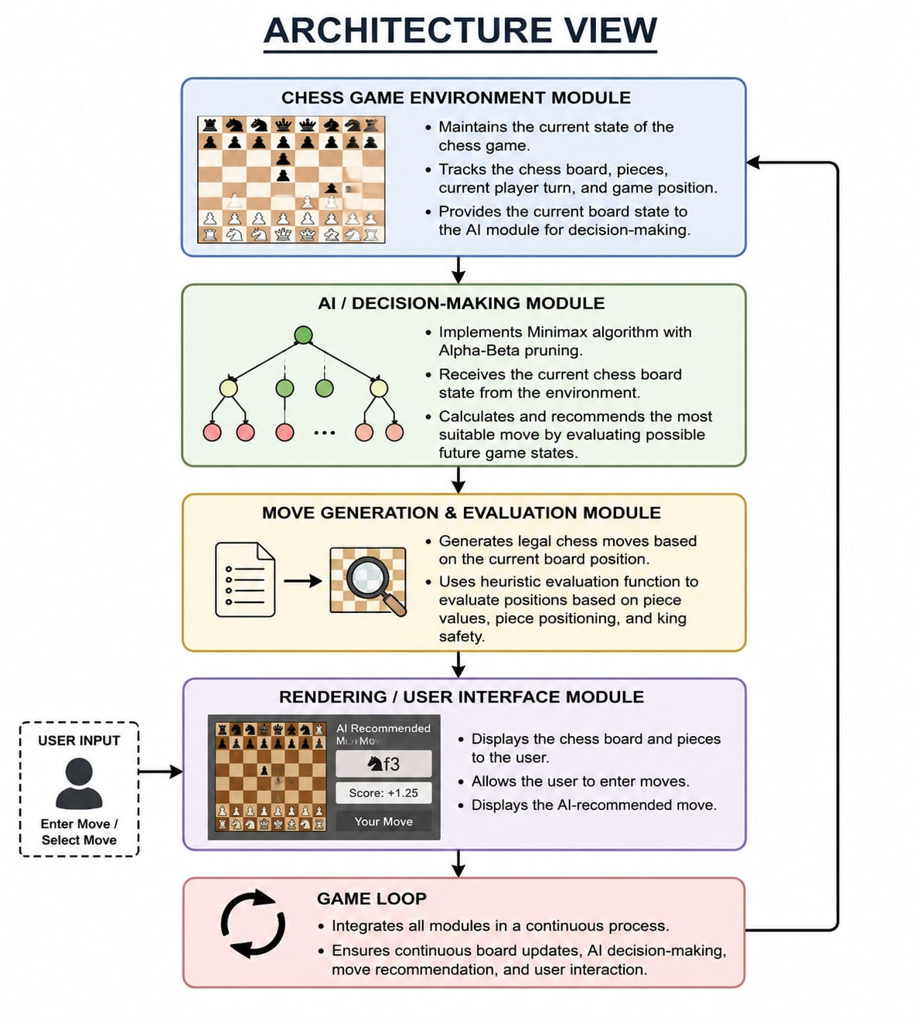

IMPLEMENTATION

  - Technologies Used

The Chess Move Recommendation System is developed using a combination of programming languages and libraries that support chess game development and Artificial Intelligence. These technologies work together to analyze chess positions, evaluate possible moves, and recommend a suitable move.

1.Programming Language
Python is used as the core programming language because of its simplicity, readability, and availability of libraries for Artificial Intelligence and chess development.
2.Chess Library
The python-chess library is used to represent the chess board, generate legal moves, validate chess rules, and manage game positions.
3.Artificial Intelligence / Algorithmic Components
The system uses the following AI techniques:
- Minimax Algorithm: Explores possible future game states and selects a suitable move.
- Alpha-Beta Pruning: Eliminates unnecessary branches from the Minimax search tree and improves efficiency.
- Heuristic Evaluation: Evaluates chess positions based on piece values, piece positioning, and king safety.

Development Tools
- IDE / Code Editor: Visual Studio Code, PyCharm can be used for coding and testing.
- Operating System: Compatible with Windows, macOS, or Linux.

Code

import chess

# Piece values

VALUE = {

chess.PAWN: 100,

chess.KNIGHT: 320,

chess.BISHOP: 330,

chess.ROOK: 500,

chess.QUEEN: 900,

chess.KING: 20000

}

# Evaluate the chess board

def evaluate(board):

if board.is_checkmate():

return -999999 if board.turn else 999999

score = 0

for piece_type, value in VALUE.items():

score += len(board.pieces(piece_type, chess.WHITE)) * value

score -= len(board.pieces(piece_type, chess.BLACK)) * value

# Center control

for square in [chess.D4, chess.E4, chess.D5, chess.E5]:

piece = board.piece_at(square)

if piece:

score += 20 if piece.color == chess.WHITE else -20

return score

# Minimax with Alpha-Beta pruning

def minimax(board, depth, alpha, beta, maximizing):

if depth == 0 or board.is_game_over():

return evaluate(board)

if maximizing:

best = -float("inf")

for move in board.legal_moves:

board.push(move)

value = minimax(board, depth - 1, alpha, beta, False)

board.pop()

best = max(best, value)

alpha = max(alpha, best)

if beta <= alpha:

break

return best

else:

best = float("inf")

for move in board.legal_moves:

board.push(move)

value = minimax(board, depth - 1, alpha, beta, True)

board.pop()

best = min(best, value)

beta = min(beta, best)

if beta <= alpha:

break

return best

# Find the best move

def get_best_move(board, depth):

best_move = None

best_value = -float("inf") if board.turn else float("inf")

for move in board.legal_moves:

board.push(move)

value = minimax(

board, depth - 1,

-float("inf"), float("inf"),

not board.turn

)

board.pop()

if board.turn == chess.WHITE and value > best_value:

best_value = value

best_move = move

elif board.turn == chess.BLACK and value < best_value:

best_value = value

best_move = move

return best_move, best_value

# Main program

board = chess.Board()

depth = 3

while not board.is_game_over():

print(board)

move, value = get_best_move(board, depth)

print("Recommended Move:", board.san(move))

print("Evaluation:", value)

user_move = input("Enter your move: ")

try:

board.push_san(user_move)

except ValueError:

print("Invalid move!")

print(board)

print("Game Result:", board.result())

Output

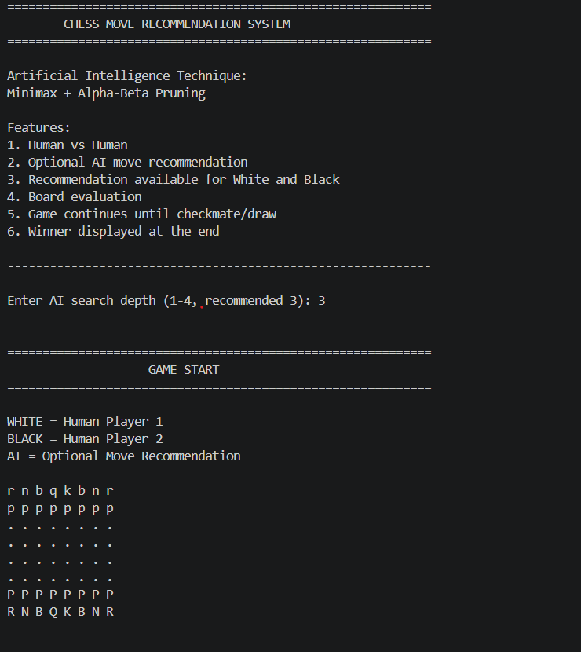

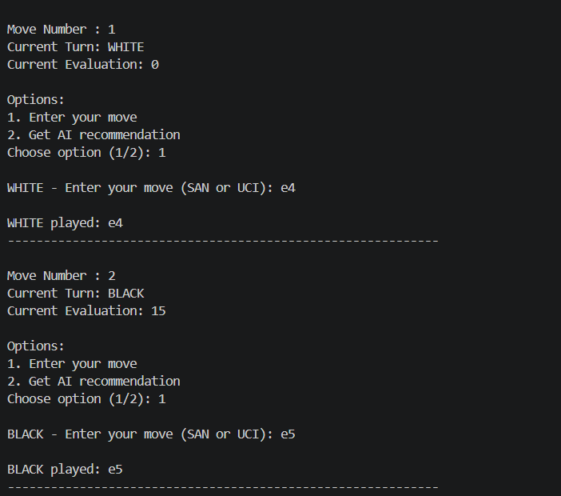

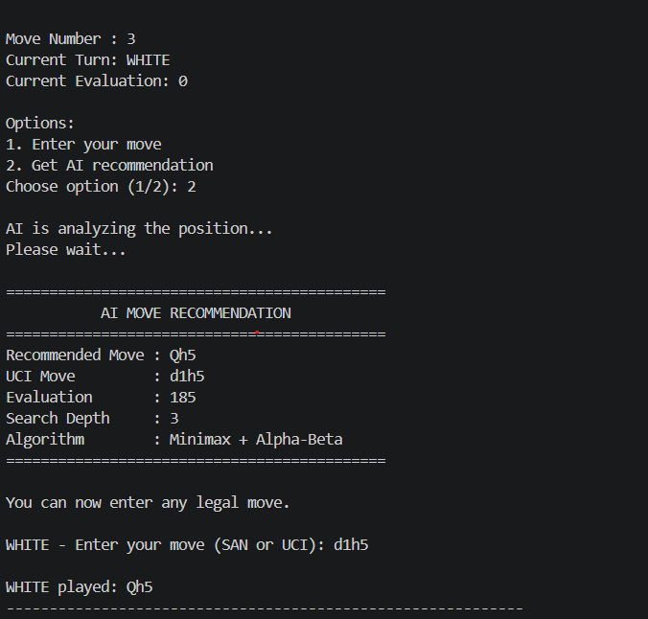
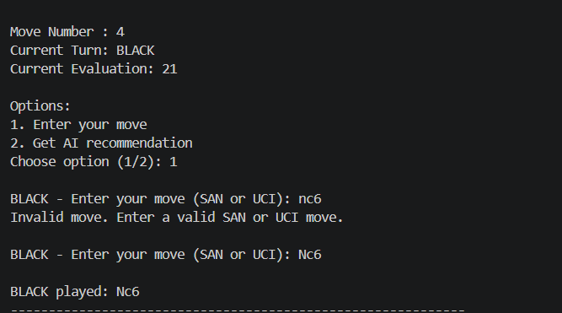

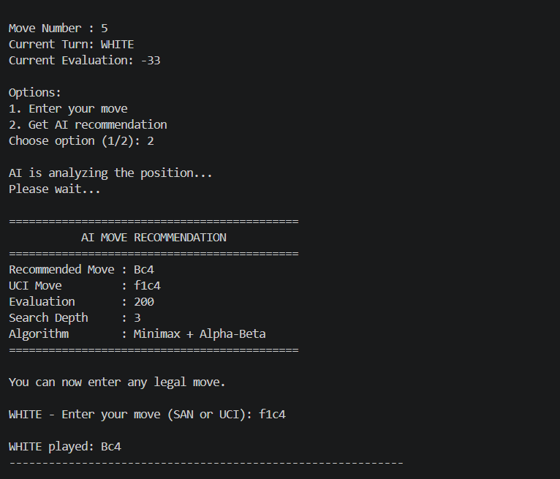

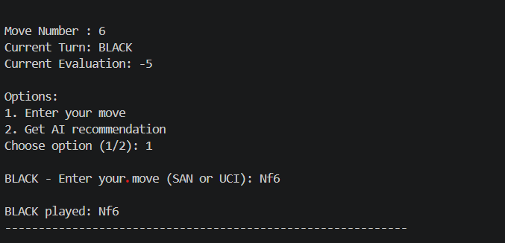

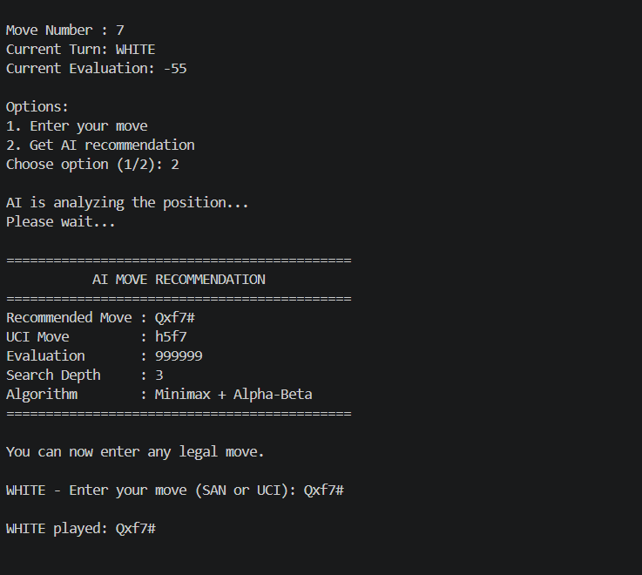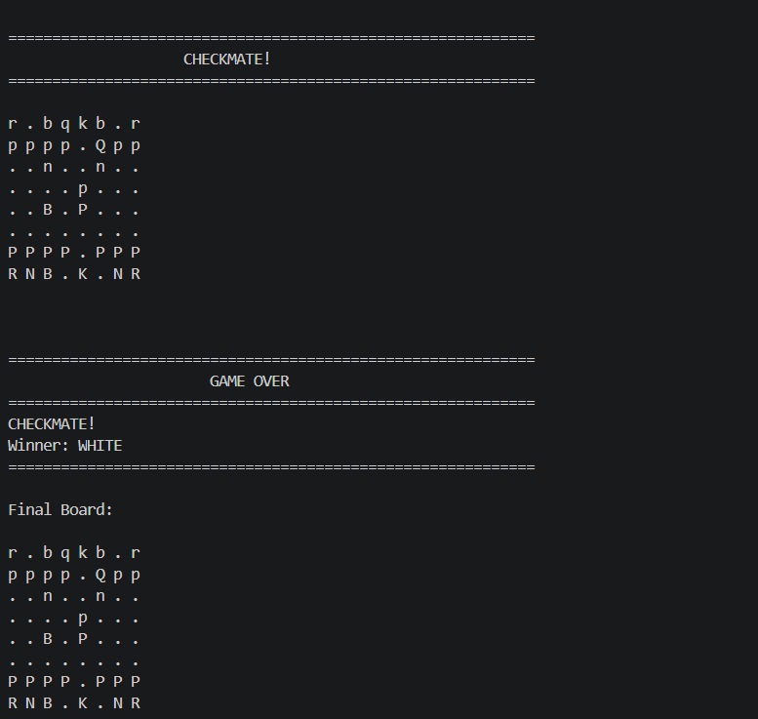

CONCLUSION

This project not only provides a chess move recommendation system but also serves as an educational platform to understand key Artificial Intelligence concepts such as search, decision-making, game theory, and heuristic evaluation. It demonstrates how AI techniques can be applied to analyze chess positions and recommend suitable moves.

Through the development of this system, we gain insights into how the Minimax
algorithm can be used to explore possible future game states and how Alpha-Beta pruning can improve the efficiency of the search process. The heuristic evaluation function helps the system assess different board positions based on factors such as piece values, piece positioning, and king safety.

The project can be further extended by incorporating more advanced AI techniques, deeper search strategies, machine learning, or reinforcement learning to improve the quality and accuracy of move recommendations.

In conclusion, the Chess Move Recommendation System bridges the gap between traditional chess gameplay and Artificial Intelligence, demonstrating how intelligent algorithms can be used to solve complex strategic decision-making problems.

REFERENCES

- Python Official Documentation
Python.org. Python 3 Documentation : https://www.python.org/doc/

- Pygame Library
Pygame.org. Pygame – Python Game Development Library https://www.pygame.org/
- Chess Board Evaluation
Chess Programming Wiki. Evaluation: https://www.chessprogramming.org/Evaluation
- Minimax Algorithm
Geeks for Geeks. Minimax Algorithm in Game Theory: https://www.geeksforgeeks.org/minimax-algorithm-in-game-theory-set-1-introduction/
- Alpha-Beta Pruning Algorithm
Geeks for Geeks. Alpha-Beta Pruning: https://www.geeksforgeeks.org/alpha-beta-pruning-in-minimax-algorithm/

